Supplementary Material

Table S1. Wind farm development phases and their spatial parameters in the Seigneurie de Beaupré area.
Wind farm | Year of operation | Capacity (MW) | Number of turbines | Access roads corridor width (m) | Turbine pad area (ha)
North | 2013-2015 | 364 | 164 | 40 | 0.5
South | Planned 2027 | 400 | 57 | 40 | 1.2
East | Planned 2028 | 400 | 57 | 40 | 1.2
West | Planned 2028 | 400 | 67 | 40 | 1.2

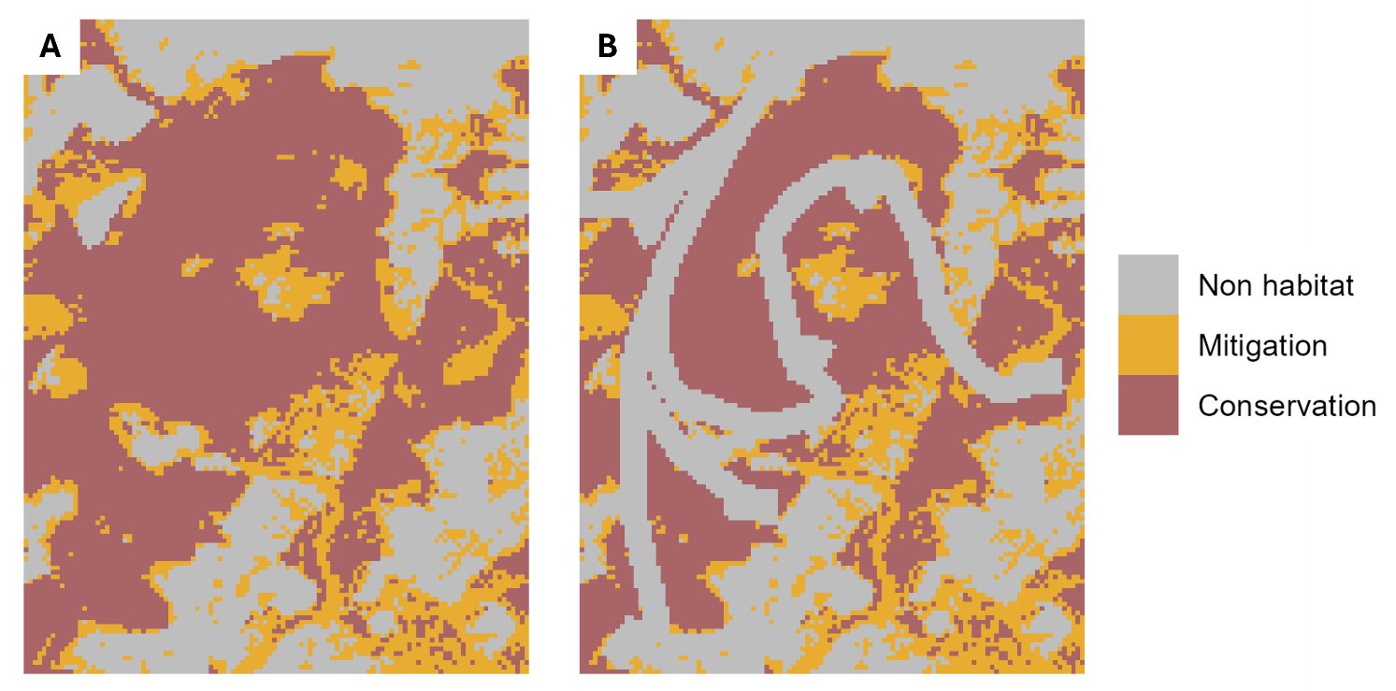Figure S1. Comparison of (A) pre-development and (B) post-development habitat classes within the North wind farm sector, based on mitigation and protection thresholds.

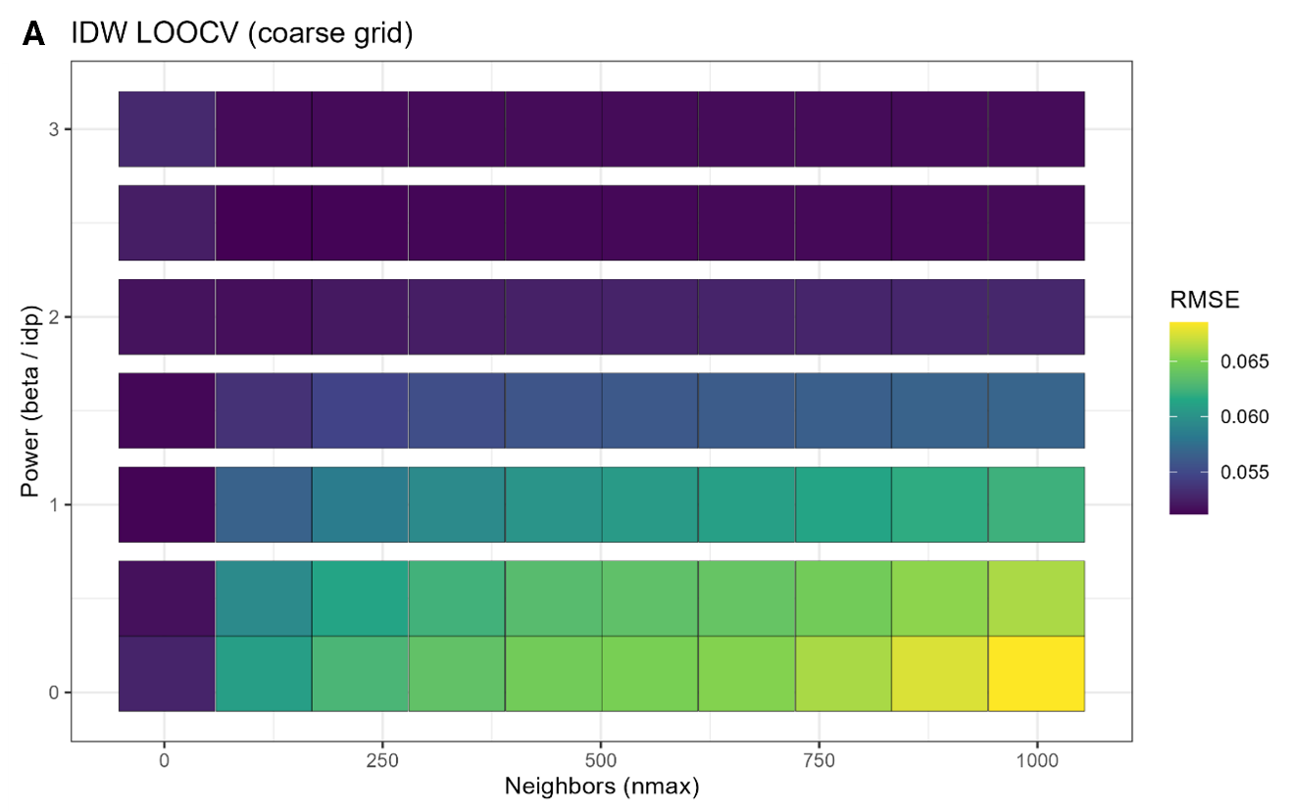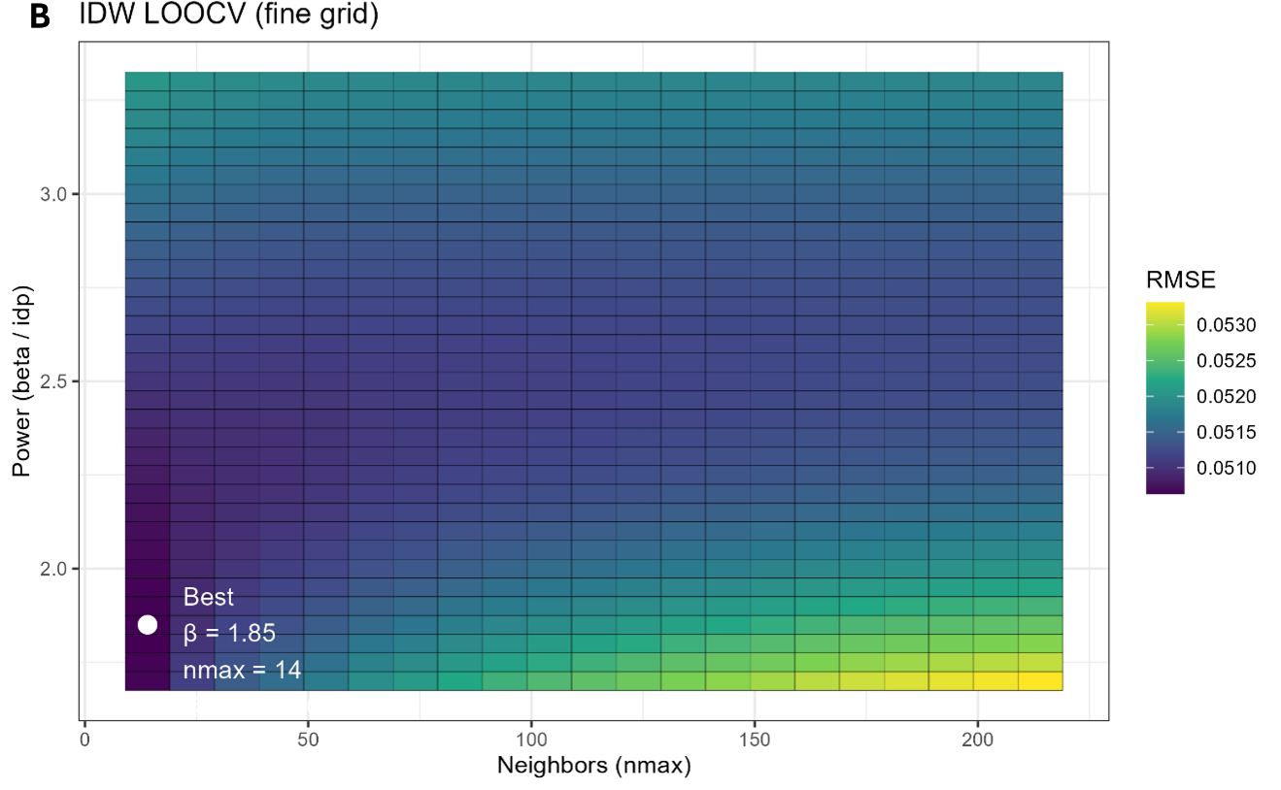
Figure S2. Leave-one-out cross-validation (LOOCV) optimization of inverse distance weighting (IDW) parameters. (A) Coarse and (B) fine grids show the RMSE surface across combinations of power (β, idp) and number of neighbors (n_{max}), with the optimal parameter set identified at the minimum RMSE.

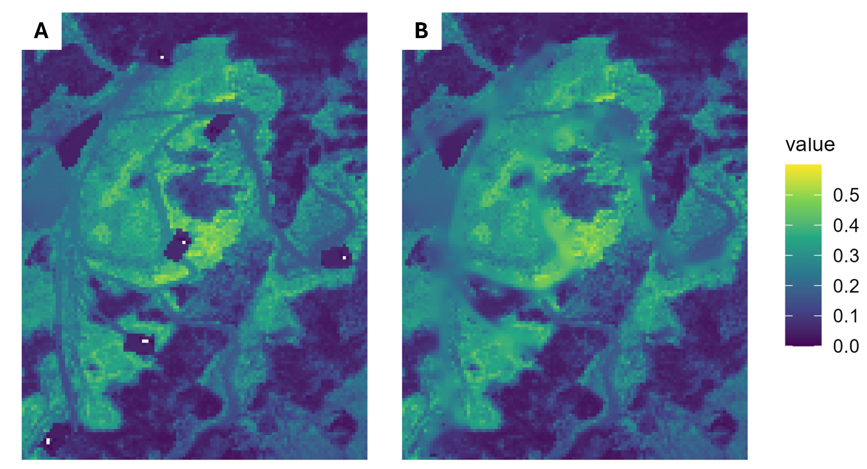Figure S3. Comparison of model predictions (A) before and (B) after IDW reinterpolation within the North wind farm sector.

